...........chetana: International Journal of Education)

CHETANA

International Journal of Education

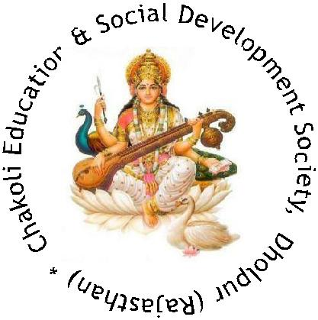

Chief Editor
Prof. A. P. Sharma

Chakoli Educational & Social Development Society, Dholpur(Rajasthan)

CHETANA
International Journal of Education

Editorial Board: Prof. O.S. Dewal
Prof. Arvind Pandey
Prof. A.P. Sharma
Dr. Anil Paliwal
Dr. Vijay Grover

Advisory Board: Dr. Alpana Sharma
Mrs. Nicole Sharma (USA)
Dr. Avinash Parashar (Canada)
Dr. SadhanaTyagi
Dr. D.P. Singh
Dr. Jai Dayal Singh
Dr. B.N. Soni

Date of Publication : August - 2016
Edition : Seventh
Cover Design : Ajay Singh Bhati
Type setting & Printing : Contact:08955890123
Institutional Subscription : Rs.Three Hundred only
Publisher : Chakoli Educational & Social
Development Society, Dholpur (Raj), India
Email:chakolisociety@yahoo.in,
&
ap_sharma 2010@yahoo.in
www.echetana.com
Editorial
Education has always been a very sensitive issue for the society and a huge area of exploration for the humankind for centuries. Evidently, a large number of exciting theories, postulates, maxims, axioms and thoughts have been put forwards by educationists time to time, have greatly influenced our mode of thinking as well as our actions gradually. The persistent conflict between the Oriental and Occidental philosophies has had a significant impact on the content and process of education. As a result, the perfectibility in education is even today a desirable phenomenon and we still have a nagging doubt in the back of our minds. Except a few exceptions, the West still generally stresses the materialism and the East emphasises the importance of spiritualism in all walks of our life. What is worth noting is the fact that these vital issues and inevitable developments have also progressively and considerably affected teacher education constantly. The recent emergence of the concept of Constructivism is a glaring example of how they (in the West) and we (in the East) look at 'Knowledge' and its branches in the present frame of cognitive encounters, conceptual implantation, meaning–making and pragmatic orientation, political culture, democratic inclination and ever changing socio-cultural contexts.
In fact, this issue of the Journal contains in addition to the above, the current challenges in the field of education caused by the latest movements and introduction of new ideas as well as acts. On account of that certain significant (research) questions have also been raised by some of our contributors for further investigation and amendments, if possible. Keeping all these issues in view, we have created, like the previous years, a separate Research Section in this issue too that essentially aims at nurturing the culture of research and helps finding answers to the questions raised by the conclusions of the research findings.
The Editorial Board is highly thankful to all the contributors, especially very eminent educationists, belonging to different walks of life and environment, who have kindly contributed to the current issue. However, the Board also reflects dispassionately that the ideas and principles reflected by the educationists and contributors in their articles, are solely their own and the Editorial Board has no responsibility towards such thought processes. Consequently, the sole responsibility lies on their shoulders, in case any dispute arises on account their reflections.
We have ventured to publish the Journal “On Line” from this year (2016) onwards to make it easily accessible to the readers and contributors within the country and abroad. We sincerely hope that the readers and contributors would continue extending their full support to the Journal by way of sending scholarly, thought-provoking articles and research papers containing original and creative ideas that are always food for thought.
The Editorial Board

